**EXPERIMENT NO –15:**

**MAKE COMPUTER LAB DESIGN IN CISCO PACKET TRACER.**

**AIM:**

**The main aim is to build an computer lab design.**

**Materials required::**

Cisco packet tracer,pc’s,server,switch.

PROCERURE::

1.Open the packet tracer.

2.Get the switch from net work devices and 4 pc’s ,including the server.

3.Put 4 pcs in order vertically ,then copy them vertically and paste them side by

Side to get 20 pc’s at least(assuming that a computer lab might be having the at least 20 pc’s).as below.

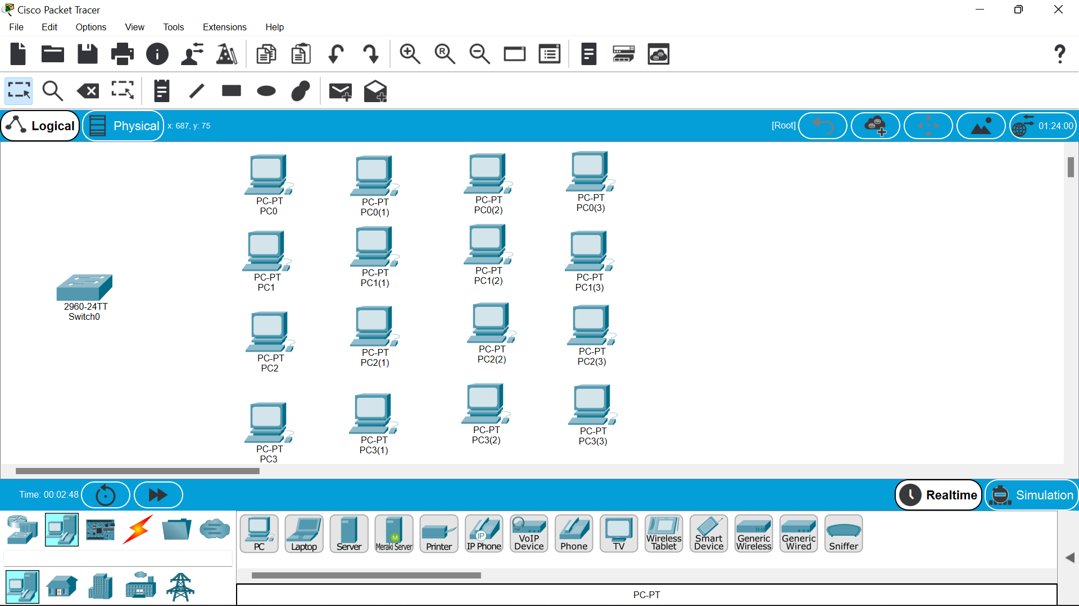

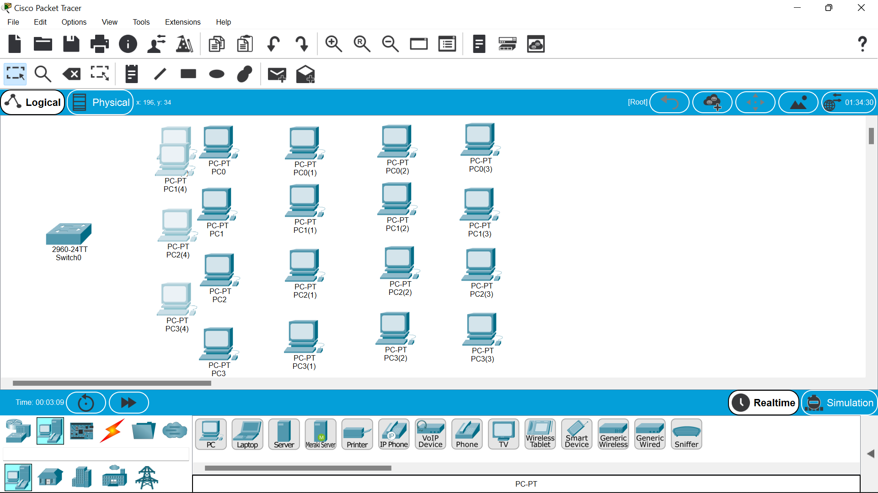

4.Then establish the connection between the switch and pc’s respectively and also between the switch and the server.

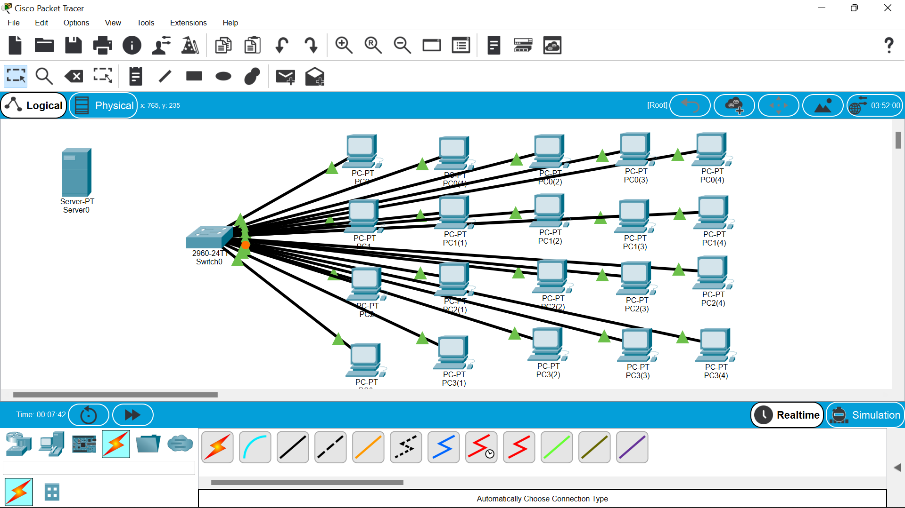

5.Also connect to the serever then ,click on the server –desktop—ip configuration.give google dns in it i.e 8.8.8.8.

6.Then enter the ip address also.

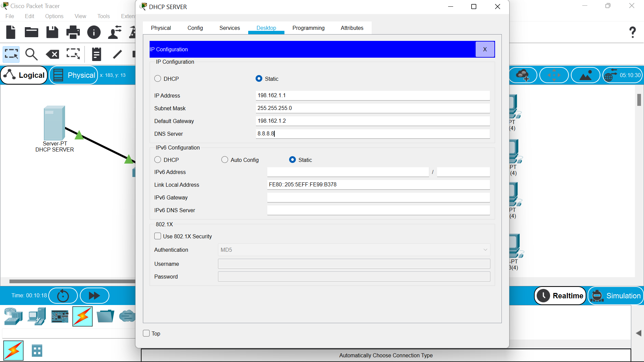

7.Go to the services DHCP—click—turn on—gateway ip—DNS as google server address—and start ip address of pc’s (just change the last decimal as below.

8.Then save the changes.

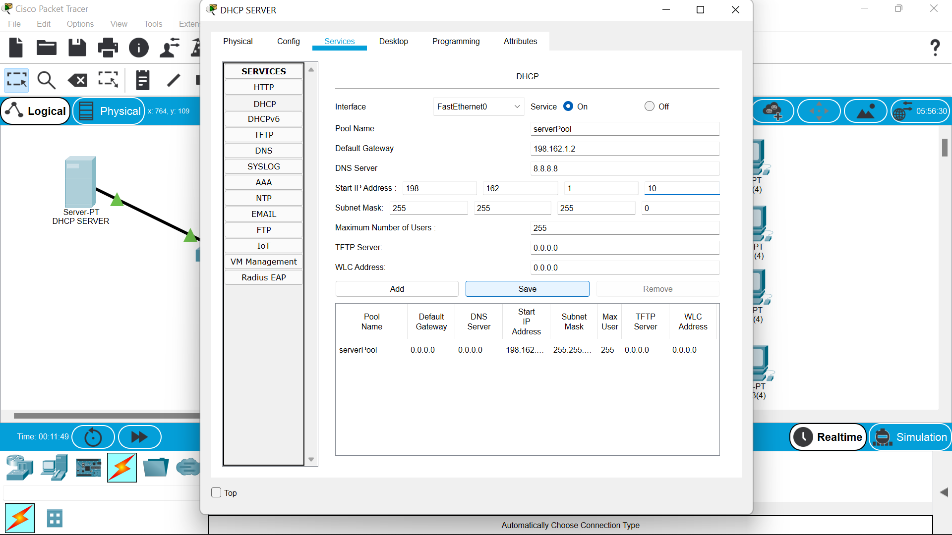

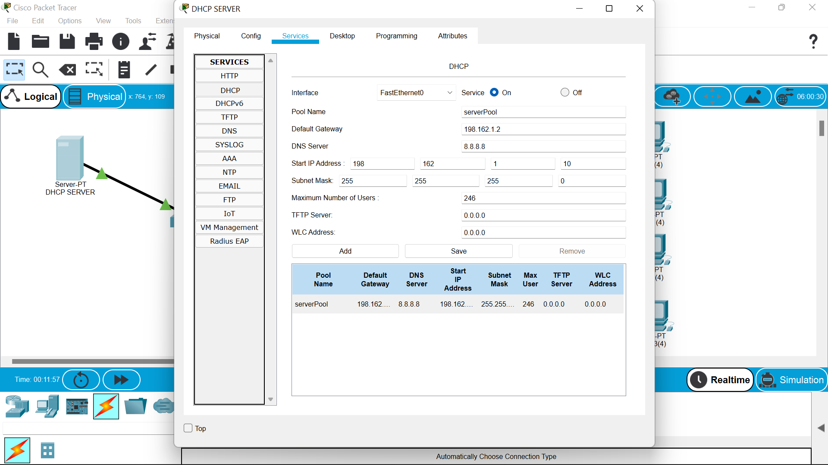

9.Now move on to the pc and go to the ip address option ,on the top you will find the DHCP click on it.

10.Now the ip address and other dns every thing will be filled automatically.

Continue this for all the 20 pc’s.

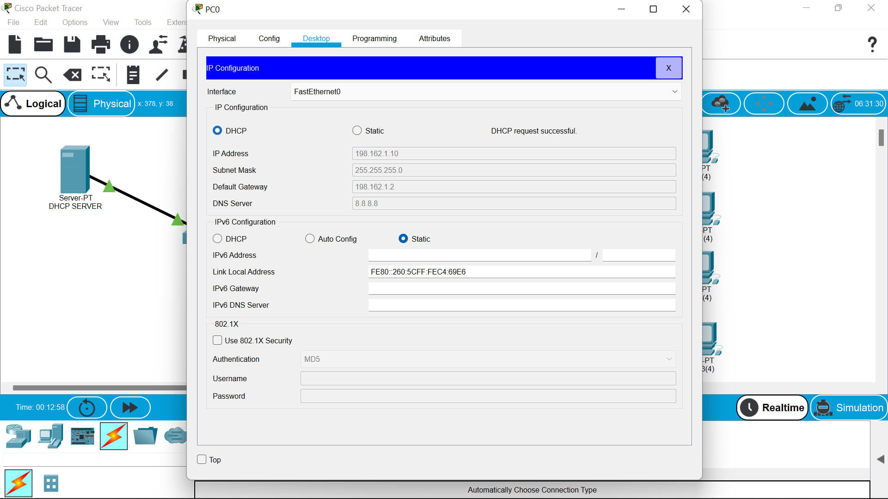

11.After this you check to transfer the message from on pc to other.

12.And we can try to run it in stimulation to view the path of the message packet.

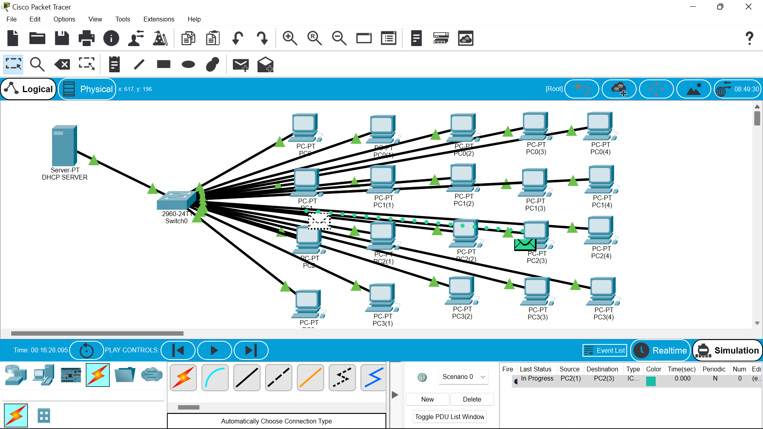

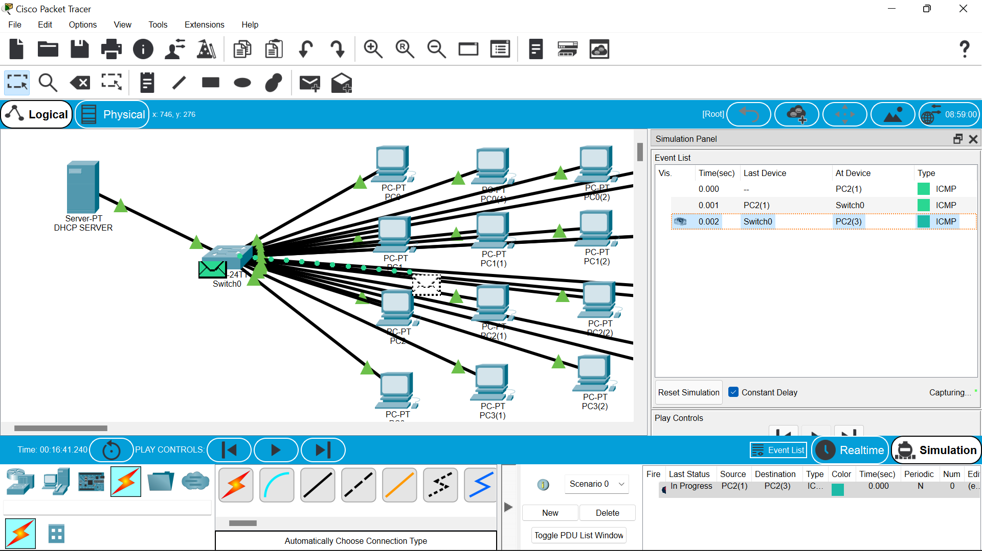

RESULT::

so finally we have successfully constructed the computer lab using cisco packet tracer ...